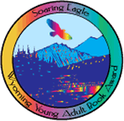
Soaring Eagle Book Award Packet
2021-2022

PHILOSOPHY:
The Soaring Eagle Book Award will provide the opportunity for Wyoming youth in grades 7-12 to select a favorite book and honor its author. The award is a joint project of the Wyoming State Reading Council and Wyoming Library Association.

PURPOSE:
To help Wyoming students in grades 7-12
- become acquainted with the best contemporary authors
- become aware of the qualities that make a good book
- choose the best rather than the mediocre
- set a goal to read at least three good books
- to honor an author whose book Wyoming students have enjoyed.

For questions please contact the Soaring Eagle Committee Co-Chairs;

Leanne Woodfill (WSRC) bunnywoodfill@gmail.com
Jeannine Collins jcollins@acsd1.org

For a full list of past nominees and winners, please navigate to:
http://www.ccgov.net/478/Soaring-Eagle-Book-Awards

