THE WYOMING INDIAN PAINTBRUSH BOOK AWARD

The INDIAN PAINTBRUSH BOOK AWARD is a joint project of the Wyoming State Literacy Association (http://wyomingliteracy.org/) and the Wyoming Library Association (www.wyla.org).

PHILOSOPHY
The Indian Paintbrush Book Award will provide the opportunity for Wyoming children in grades four through six to choose their favorite book from a list of 10 nominees, and honor its author.

PURPOSE
- To help children become acquainted with the best contemporary authors.
- To help children become aware of the qualities that make a good book.
- To accustom younger children to concepts of choice, critical reading, and voting procedures that will help them participate in choosing other awards.
- To honor an author whose book has been enjoyed by children in Wyoming.

HOW BOOKS ARE CHOSEN FOR THE LIST
The annually nominated titles will be chosen by Wyoming students in grades 4-6, based upon the following nomination guidelines:
- Books may be fiction or nonfiction, and in any format (e.g. novel in verse, graphic novel).
- The book must currently be in print & have a copyright date within the last 5 years.
- Books must be in print at the time of nomination.
- Books must be nominated by Wyoming students in grades 4-6.
- Only one title per author will be included on the nominations list.
- No author can be on the list for two consecutive years.
- No title can be on the nominees list more than once.
- Deadline for nominations is March 1, 2024

VOTING FOR THE INDIAN PAINTBRUSH AWARD BOOK
- Wyoming children from 4th through 6th grade are encouraged to read or listen to as many of the nominated books as possible and to vote for their favorite.
- Each participating child will vote for only one book.
- Participants must have read or listened to at least 3 books to be an eligible voter.
- The Indian Paintbrush Book Award voting will take place online, beginning in January.
- Submit book totals in the survey found on the Wyoming Book Awards website.
- A child may vote only once. Deadline for voting is March 15, 2024.
- If you have any questions, please contact the co-chairs or any other committee members:

Co-Chairs:
Whitney Luciano, wluciano@ccsd1schools.net
Rebecca Jones, Rebecca.Jones@campbellcountywy.gov
Committee Members:
Kennedy Penn-O'Toole, kpennotoole@albanycountylibrary.org
Michelle Humber, mhumber@sublettecountylibrary.org
Becky Davis, bdavis@park6.org
Amy Preston, apreston@park6.org
Daniel Primich, dprimich@tcsd.org
Linda Herget, lherget@lccc.wy.edu

2023-2024 Indian Paintbrush Award Ballot
Deadline to enter votes: March 15, 2024
Please tally the votes from your school/institution. Put the total number of votes for each book beside the title. Then enter your total school/library tally for each book into the online survey, available in January (wyla.org/Wyoming-Book-Awards)

Vote | Title & Author | Vote | Title & Author
 | Ali Cross  by James Patterson  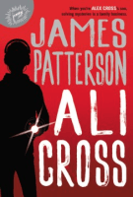 |  | The Aquanaut  By Dan Santat  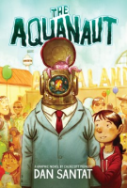
 | Mac Undercover  by Mac Barnett  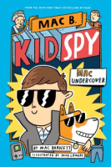 |  | Odder  by Katherine Applegate  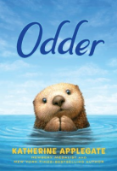
 | A Rover’s Story  by Jasmine Warga  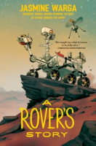 |  | Stay  by Bobbie Pyron  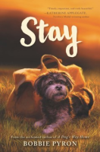
 | Torpedoed  by Deborah Heiligman  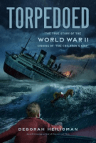 |  | The Total Eclipse of Nestor Lopez  by Adrianna Cuevas  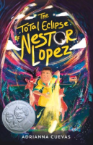
 | Tristan Strong Punches a Hole in the Sky  by Kwame Mbalia  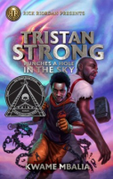 |  | Wreck at Ada’s Reef  by Michael D. Biel  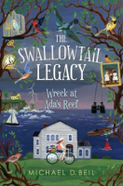

2023-2024
Indian Paintbrush Award Nominees
Read 3 or more to vote! Voting deadline: 3/15/24
Ali Cross  by James Patterson | The Aquanaut  by Dan Santat
Mac Undercover  by Mac Barnett | Odder  by Katherine Applegate
A Rover’s Story  by Jasmine Warga | Stay  by Bobbie Pyron
Torpedoed by Deborah Heiligman | The Total Eclipse of Nestor Lopez  by Adrianna Cuevas
Tristan Strong Punches a Hole in the Sky  by Kwame Mbalia | Wreck at Ada’s Reef  by Michael D. Biel

2023-2024
Indian Paintbrush Award Nominees
Read 3 or more to vote! Voting deadline: 3/15/24
Ali Cross  by James Patterson | The Aquanaut  by Dan Santat
Mac Undercover  by Mac Barnett | Odder  by Katherine Applegate
A Rover’s Story  by Jasmine Warga | Stay  by Bobbie Pyron
Torpedoed by Deborah Heiligman | The Total Eclipse of Nestor Lopez  by Adrianna Cuevas
Tristan Strong Punches a Hole in the Sky  by Kwame Mbalia | Wreck at Ada’s Reef  by Michael D. Biel

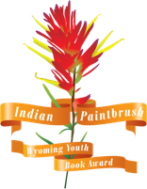  Indian Paintbrush Winner  2022-2023 |  | Indian Paintbrush Nominee  2023-2024 |  | Indian Paintbrush Nominee  2023-2024
Indian Paintbrush 1st Runner Up  2022-2023 |  | Indian Paintbrush Nominee  2023-2024 |  | Indian Paintbrush Nominee  2023-2024
Indian Paintbrush 2nd Runner Up  2022-2023 |  | Indian Paintbrush Nominee  2023-2024 |  | Indian Paintbrush Nominee  2023-2024
Indian Paintbrush Nominee  2023-2024 |  | Indian Paintbrush Nominee  2023-2024 |  | Indian Paintbrush Nominee  2023-2024
Indian Paintbrush Nominee  2023-2024 |  | Indian Paintbrush Nominee  2023-2024 |  | Indian Paintbrush Nominee  2023-2024
Indian Paintbrush Nominee  2023-2024 |  | Indian Paintbrush Nominee  2023-2024 |  | Indian Paintbrush Nominee  2023-2024
Indian Paintbrush Nominee  2023-2024 |  | Indian Paintbrush Nominee  2023-2024 |  | Indian Paintbrush Nominee  2023-2024
Indian Paintbrush Nominee  2023-2024 |  | Indian Paintbrush Nominee  2023-2024 |  | Indian Paintbrush Nominee  2023-2024
Indian Paintbrush Nominee  2023-2024 |  | Indian Paintbrush Nominee  2023-2024 |  | Indian Paintbrush Nominee  2023-2024
Indian Paintbrush Nominee  2023-2024 |  | Indian Paintbrush Nominee  2023-2024 |  | Indian Paintbrush Nominee  2023-2024  4

